General Code:

% Rocket Project, Take 1

% Deepak Warrier

% September 22, 2016

clc;

clear all;

close all;

g = 9.8; % acceleration of gravity

thrust = 50; % thrust of the rocket motor in Newtons (kg\*m/s^2)

mass = 2; % mass of the rocket in kg

burnTime = 30; % burn time of the rocket in seconds

stopTime = 300; % time (in seconds) when the simulation stops

timeStep = 0.1; % time step size for the simulation (every 0.1 seconds)

v(1) = 0; % rocket velocity in m/s

vY(1) = 0; % Velocity in x direction

vX(1)= 0; % Velocity in y direction

downRange(1) = 0; % rocket downRange in m

altitude(1) = 0; % rocket altitude in m

time(1) = 0; % time since launch, in seconds

angle = 85;

i=1;

while(altitude(i)>=0)

if(time(i)<=burnTime)

vY(i+1)=vY(i)+((thrust\*sind(angle))/mass-g)\*timeStep;

vX(i+1)=vX(i)+(thrust\*cosd(angle)/mass)\*timeStep;

else

vY(i+1)=vY(i)-g\*(timeStep);

vX(i+1)=vX(i);

end

avgVelY=(vY(i+1)+vY(i))/2;

avgVelX=(vX(i+1)+vX(i))/2;

v(i)=(vX(i+1)^2+vY(i+1)^2)^.5;

downRange(i+1)=downRange(i)+avgVelX\*timeStep;

altitude(i+1)=altitude(i)+avgVelY\*timeStep;

time(i+1)=time(i)+timeStep;

i=i+1;

end

disp('Max Down Range' max(downRange), 'Max Altitude' max(altitude), 'Max Horizontal Velocity' max(vX), 'Max Vertical Velocity' max(vY), 'Max Velocity' max(v), 'Total time' max(time));

plot(time, altitude, time, downRange);

title('Altitude/Distance v, Time @ 85 degrees');

xlabel('Time (in seconds');

ylabel('Altitude/Distance (in meters)');

Output for 85°:

Max Down Range in m

7889.7736

Max Altitude in m

1.7274e+04

Max Horizontal Velocity in m/s

65.3668

Max Vertical Velocity in m/s

453.1460

Max Velocity in m/s

586.3688

Total time in s

135.7000

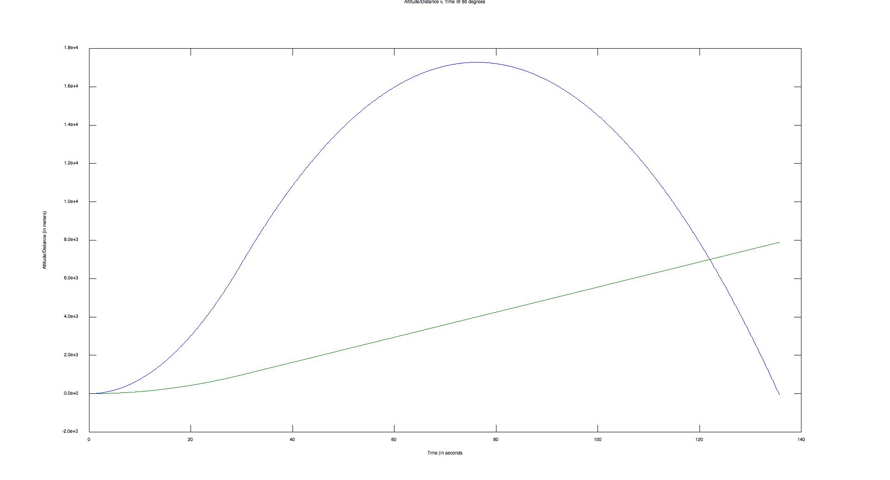

Output for 80°:

Max Down Range in m

1.5485e+04

Max Altitude in m

1.6755e+04

Max Horizontal Velocity in m/s

130.2361

Max Vertical Velocity in m/s

444.6058

Max Velocity in m/s

588.2131

Total time in s

133.9000

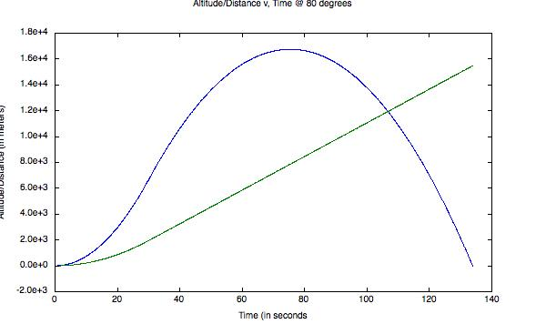

Output for 75°:

Max Down Range in m

2.2517e+04

Max Altitude in m

1.5910e+04

Max Horizontal Velocity in m/s

194.1143

Max Vertical Velocity in m/s

430.4444

Max Velocity in m/s

592.0803

Total time in s

131.0000

